AAUP ALERT
Colorado Conference
Spring 2024 Newsletter
Contents
- President’s Message
- Save Date: AAUP Annual Meeting
- Meet Michael DeCesare
- Presidential Searches
- Chapter News
- Legislative Report
- Colorado Views
- Conference Leadership
President’s Message
The chapters of the Colorado Conference continue to vigorously defend AAUP principles on their campuses as this newsletter reports. Even as shared governance challenges have mounted on Colorado campuses public and private, AAUP faculty are leading the charge in challenging administrations to abide by AAUP principles in executive searches and campus operations. In this respect, our conference continues to punch above its weight. I am pleased to report that contrary to earlier expectations we will have a delegate, Denver University associate professor of education, Cecelia Ophan, representing us at the AAUP Biennial Conference in Alexandria, VA—this on the strength of strong chapter growth at D.U. I am also pleased to invite all our AAUP members and their faculty colleagues to attend our annual meeting, scheduled for Saturday, June 24, on the D.U. campus. See you there!
Steve Mumme

Annual Meeting June 29: Save the Date

The annual meeting of the AAUP Colorado Conference will be held on Saturday, Jume 29 at Denver University’s SIE building—Room TBA. We are honored to have Dr. Michael DeCesare from the national AAUP and an expert on problems of shared governance in American colleges and universities as our keynote speaker.

Meet Michael DeCesare
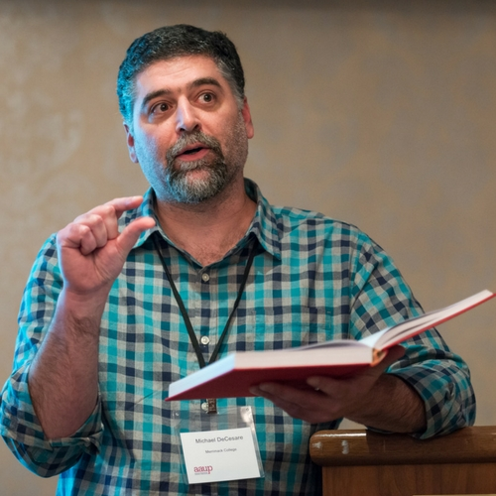

Michael DeCesare is senior program officer in AAUPs department of academic freedom, tenure, and governance. Before joining AAUPs permanent staff he served as president of Merrimack College’s AAUP chapter as well as serving a 4-year term as an elected member of the National Council with service on multiple committees including chair of the AAUP’s Committee on College and University Governance and the AAUP Foundation’s Academic Freedom Fund Governing Board. DeCesare’s scholarly work focuses on the sociology of education and on social movements. He is the author of A Discipline Divided: Sociology in American High Schools and Death on Demand: Jack Kevorkian and the Right-to-Die Movement. His article, Reaffirming the Principles of Academic Government is a forceful exposition and defense of AAUP’s historic principles advancing shared governance at American colleges and universities (https://www.aaup.org/article/reaffirming-principles-academic-government).

Presidential Searches Draw Criticism

If recent presidential searches at Colorado colleges and universities are the measure, then both shared governance and public accountability for these decisions are in peril. A series of searches this past year, at UC Boulder, UC Colorado Springs, CSU-Pueblo, DU, and Colorado Mountain College show serious backsliding from AAUP Rebook best practice for choosing chief executives at higher education institutions.

To capture the highlights (more accurately, the lowlights), the common thread in these questionable searches is a lack of transparency and marginalization of faculty input in appointing executives at these institutions. At CU, for example, President Todd Saliman, formerly chief budget officer, was appointed CU System interim president in June 2021 and ten months later identified as sole finalist for the position from a pool of five finalists for the office—the other four unidentified, though it is believed that the head of the Colorado’s community college system, Joe Garcia, was in that pool. Though comments on his suitability from system stakeholders were solicited in the month preceding his appointment, the appointment process was opaque. This April, a similarly masked process was used to hire Justin Schwartz as chancellor for the Boulder campus. The other finalists for the position remain unknown to the faculty, students, or the public-at-large (Denver Post, April 5, 2024).

That appointment was preceded by another questionable appointment at UC Colorado Springs (UCCS). There, in January, CU System head Todd Saliman selected UCCS interim chancellor, Jennifer Sobanet, after the campus search committee identified five finalists from which Saliman choose two for campus interviews. Sobanet, a former executive vice-chancellor at CU Denver, was not on the finalist list or among the ones selected for interviews but did have a close working relationship with Todd Saliman. Saliman justified his choice claiming extraordinary circumstances and lack of fit among the finalists and candidates interviewed. The full list of candidates remains cloaked.

At CSU-Pueblo, Armando Valdez, president of the CSU System governing board, was appointed as president in December 2023 with limited faculty input after a search resricted to in-state candidates produced no viable candidates, at least according to CSU System chancellor, Tony Frank. Responding to CSU-Pueblo AAUP’s request for an AAUP review, Michael DeCesare, Senior Program Officer at AAUP headquarters, noted that that CSU-Pueblo’s confidential search “is entirely inconsistent with … AAUP policy standards regarding confidentiality and presidential searches”, and B) “that the geographic restrictions on the scope of CSU-Pueblo’s presidential search would appear to have the potential to impede efforts to both ‘maximize the pool of viable candidates’ and ‘solicit nominations for all segments of the population.’

Colorado Mountain College arguably suffered an even worse fate. When CMC’s president, Carrie Hauser, announced her departure on March 22, 2024 the Board of Trustees announced an internal search to be concluded in just two weeks and asked all CMC personnel to complete an online survey to express their opinions on the search. Subsequently, on April 15, the board announced the appointment of Matt Gianneschi, formerly chief operating officer, to the presidency effective August 1, 2024. When challenged by the CMC’s AAUP chapter, the BOT president, Peg Portscheller dismissively suggested that faculty participate in the online survey as if that was a sufficient genuflection to shared governance. It hardly bears saying that the entire process was a gross violation of AAUP principles.

The disregard for longstanding principles of shared governance in these Colorado searches is directly traceable to disastrous legislation, HB 21-1051, that the General Assembly enacted in 2021. The law allows presidential searches at public universities to select sole-finalist in a cloaked, non-transparent manner, circumventing public scrutiny and, arguably, shared governance. Finalists need not be named. Polis didn’t veto this legislation and allowed it to become law sans-governor’s signature. Even the Denver Post’s editorial board lambasted the decision stating: “Today, the standard practice is for universities and colleges to name a single finalist which results in a sham public vetting before the final offer of employment is made” (Denver Post, April 5, 2024). They may as well have said “a sham faculty vetting” as well.

Clearly, our Colorado Conference has work to do in pressing for legislative change affecting executive searches in public universities in Colorado. As important an agenda as this is, unfortunately, legislative change doesn’t reach to private institutions like DU, where board fiat similarly ran roughshod over faculty voice in its latest presidential search. All this is graphic evidence of the imperative that faculty push back on these corporate and hierarchical trends eroding shared governance in Colorado. It may be the work of Sisyphus but it’s vital work that must be done.

Chapter News
AAUP-CSU Fort Collins focused on two issues this year: the assessment of a new university budget model and labor, education, and democracy. Last year, CSU announced that the institution would adopt a hybrid Responsibility Center Management model in an attempt to stave off the effects of the “demographic cliff” and redirect resources to “areas of growth.” Our chapter decided to explore the potential consequences of this redesign by consulting with faculty at universities that had already adopted the model. Andrew Du spearheaded this event, and invited AAUP members from Rutgers, Kent State, Indiana, and Temple to participate in an on-line panel that was open to all. The panelists alerted us to a range of potential problems with the model that will help inform our response to its implementation.
The second initiative was arranged in conjunction with CSU’s thematic Year of Democracy (see photos below) during which events were organized by various units on campus and the contributions emphasized labor and workplace democracy. AAUP-CSU’s initiated and coordinated this effort which was supported financially by the AAUP State Conference, AFL-CIO, Northern Colorado Labor Council, and the College of Liberal Arts. All of the events were cosponsored by the above as well as United Campus Workers (UCW) and COWINS. The first event, Workplace Democracy: Perspectives from Colorado Educators, was a panel organized by UCW members Kendall Stephenson and Brendan Davidson, and moderated by Gretchen Steidley, included representatives from the Center for the Study of Academic Labor, AAUP-CSU, UCW, COWINS, and the Colorado Education Association. Panelists were asked to discuss the challenges to and opportunities for workplace democracy in educational settings. The second event was a keynote lecture by Lane Windham on Workplace Democracy: Inequality and the Future of U.S. Labor, organized by Dimitris Stevis and Mary Van Buren. Lane is the Associate Director of the Kalmanovitz Initiative for Labor and the Working Poor at Georgetown; she provided an overview of the decline and recent resurgence of labor in the U.S. The final event, organized by Gretchen Steidley, was a performance by the Chicano funk band, Los Mocochetes, whose energetic, danceable music promotes positive social change. It was a celebratory ending to a very busy week!
Our most recent task was unanticipated, but also related to democracy. The CSU chapter of Students for Justice in Palestine have been demonstrating regularly over the last few months, and on April 29 delivered a letter to the university president, demanding, among other things, divestment from companies supporting the war in Gaza. Given the violent response to protestors on other campuses, CSU-AAUP wrote a letter to the administration emphasizing the students’ right to free speech and stating our expectation that the university would refrain from calling in the police. Thus far the students, counter-protestors, and campus police have all been peaceful, although an encampment has not been established. Mary Van Buren reporting.
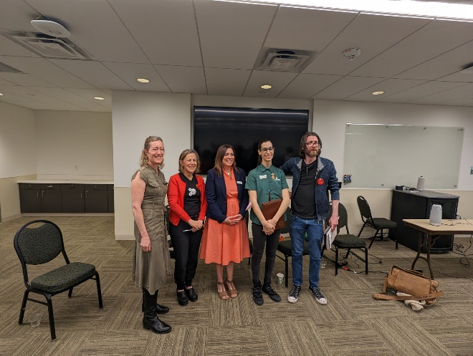Panel on Workplace Democracy

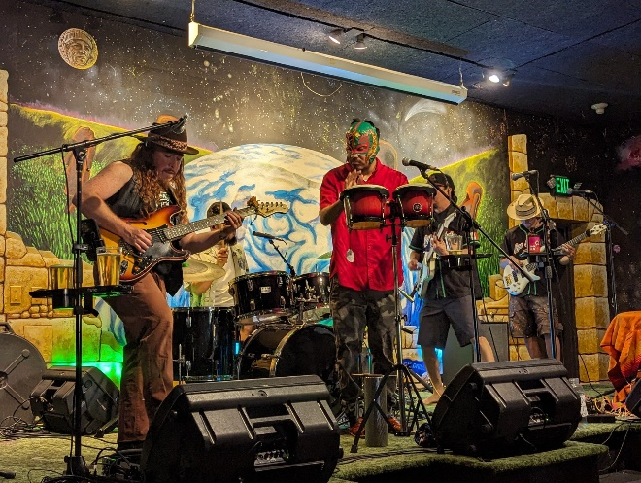Los Mocochetes Perform at Avogadro’s in Ft. Collins
AAUP CSU-Pueblo. Led by AAUP faculty, CSU-Pueblo scored a victory in late April when their faculty senate resolved to peg faculty salaries to the median salaries at peer institutions. Salaries at all faculty ranks have lagged peer institutions for years. The initiative gathered steam after an analysis CSU Pueblo AAUPer and Assistant Professor Heidi ReynoldsStenson found that 93% of CSU Pueblo faculty members found it necessary to their salaries, over half reported taking a second job, and 49% had passed on needed medical care to shave expenses.51% of faculty have taken a second job and 49% have passed on needed medical care to shae expenses.
Many AAUP members played a vital role in getting that resolution before and through the Faculty Senate. Two members of our chapter are on the Faculty Compensation Committee. Multiple AAUP members on the Faculty Senate argued for the resolution at the meeting. Heidi's study is cited again.

The CSU Pueblo AAUP is the reason that there was a reporter at that meeting in the first place. For more information see this piece in the Pueblo Chieftain (PressReader.com - Digital Newspaper & Magazine Subscriptions). Jonathan Rees reporting.

AAUP Colorado Mountain College
Chapter members are disturbed by the administrative approach to selecting a new president to replace the outgoing president,
Carrie Houser. After little more outreach than an emailed faculty survey substituting for meaningful faculty engagement in the search, CMC’s chief operating officer, Matt Gianneschi was named to lead CMC’s dispersed campuses. As the chapter in its letter to the board of trustees noted, the short two-week internal search void of meaningful faculty input represents a serious departure from AAUP’s prescribed best practices for presidential searches. (see Presidential Seach piece above). Dave Ruffley reporting.

AAUP U.C. Colorado Springs. UCCS wrestled with the dual challenge of closed presidential search and budget recissions in the winter-spring of 2023-24. See, the Presidential Search piece above and the budget discussion by Karen Larkin below in Colorado Views. Steve Mumme synopsis.

AAUP Front Range CC-Westminster. We have a multi-year campaign designed by Justin DePaolis-Metz of AFT to build our chapter and build faculty power. We now have a nine-person organizing committee, the members of which are based on the Westminster and Larimer campuses of FRCC, and we will be participating in Zoom training sessions over the summer in addition to our regular committee meetings and other activities.

With the AFT we also hosted an online panel discussion, "In Case of Emergency," moderated by the faculty senate presidents from our Boulder, Larimar, and Westminster campuses. The 90-minute event featured activists from the AAUP Ohio State conference, the Faculty and Staff Federation of the Community College of Philadelphia, and West Virginia University. The speakers focused on lessons learned from recent attacks to due process and let participants know what structures they wish had been in place before these attacks occurred.

We plan to send three chapter members to this year's Summer Institute and to seek funding for more paid organizers, in addition to the wonderful Estee Marchi. Meanwhile, the administration continues to be tone-deaf, or just deaf in general to faculty attempts to engage in shared governance. Stay tuned: changes, good and bad, may be on the horizon. Mark DuCharme and Melinda Myrick reporting.

Legislative Report
The Colorado General Assembly concluded its 2024 legislative session with little to show for improvements in faculty working conditions, or higher education generally. A survey of major legislative accomplishments by the Colorado Sun (Colorado legislature: Top 101 bills that passed, failed in 2024 (coloradosun.com)) found zero mentions of high ed in its inventory of consequential legislative measures considered and passed this year. Of eight higher ed bills enacted, the transparency bill (SB 24-174) that modifies GT Pathways procedures may be of greatest interest to faculty inasmuch as it amplifies and streamlines student course transfers and allows student appeals of adverse transfer decisions, among other actions (https://leg.colorado.gov/bills/sb24-164).

Colorado Views

Budget Reform at UCCS
Karin Larkin

Like most institutions in Colorado, UCCS has been experiencing budget cuts and poor administrative decision making related to the allocation of resources for years (really decades). Given the climate of higher education in the U.S. today, our AAUP Chapter wanted to make sure our members were well versed in the history and organization of our campus budget given that we have been asked to provide input on impending budgetary shortfalls and cuts.
To that end, our chapter elected in May 2023 to commission a forensic budget analysis to be completed by Dr. Howard Bunsis. Dr. Bunsis is Professor of accounting and faculty advisor for accounting club and Beta Alpha Psi at Eastern Michigan University and has been conducting budget analyses for a number of universities over the past several years for AAUP. In the summer 2023, our chapter engaged in a GoFundMe campaign to raise the funds needed to commission Dr. Bunsis. With the support of AAUP State Conference, UCW, and 39 individual donors, we were able to quickly raise the funds. In October, we received Dr. Bunsis’s report which consisted of 85 PowerPoint slides with data analysis and interpretation on our income, expenditures, asset breakdown, enrollment trends, salary trends, and comparisons to peer institutions.
We shared this report with our membership and in November, Dr. Bunsis presented his results to approximately 35 AAUP members and donors. He also addressed questions from that group, which we used to clarify our understanding of and dig deeper into the results. Using the information provided by Dr. Bunsis and the answers to our questions, a small committee from the AAUP leadership put together a presentation for the campus to highlight the most important points. We scheduled an open forum for February to present the data to the campus faculty and solicit input. We also used the event to recruit more AAUP members to our chapter. We invited the Chancellor to attend the presentation portion of the meeting only, which she attended. We also invited the Faculty Assembly President and both chairs of our Faculty Assembly Committee on the Budget and University Budget Advisory Committee to attend both the presentation and the discussion. Given that our event fell on the Tuesday after the horrific shooting on our campus, the attendance was very good. We had approximately 50 people in attendance with representation from 5 of our 7 colleges.
We had three main takeaways and several questions to administration based on our analysis and discussion. I’ll highlight a few here because I believe most the AAUP membership can relate to these. I will highlight three main takeaways. First, we would like more transparency in our budget resource allocation and we request that the Administration reframe the constant narrative of a “budget crisis.” We have been told for the past 15 years that we have a “budget crisis” and need to cut, even during years of growth. Looking at the actual numbers, we have solid reserves, cash flows, bond ratings, and manageable debt (but they need to stop building buildings, especially ones that do not significantly contribute to instructional space). Our State appropriations and funding are bad, but have been improving. We do not have to jump off the “demographic cliff!” Instead have opportunities if we are more strategic in how we allocate our resources. We feel like the administration asks us to participate in cutting (perhaps to deflect the blame), but they do not ask (or listen to faculty) input on how to invest our resources. They generally make those decisions based on outside influence (“community partners” or donors) without robust discussion with faculty on how it may impact the university as a whole. They have relied on “one time funds” at the expense of the our core academic mission. Along those lines, our second main point is that budget does not reflect a dedication to our academic mission. We underfund academics compared to other units and especially compared to “administration.” We have administrative bloat. We have an over reliance on contingent faculty. Faculty are underpaid compared to our peers and our salaries are not keeping up with inflation. Administrative salaries have increased by 88.8% over the past 10 years compared to faculty salaries at 48.2% increase over that same period. Our final point is that our budgets are a mess. UCCS budget data is impossible to track and interpret because it is tied to the CU System. We requested an audited budget for our individual campus. Our campus administration is also not responding well to issues flagged by IPEDS due to the lack of transparency in our budget.
The campus forum resulted in a list of points and questions for our Administration and shared governance groups. We have shared the list of concerns and suggestions with our Chancellor, UBAC, Faculty Assembly Committee on the Budget, and Faculty Assembly Executive Committee. Our Administration and shared governance groups have been very responsive, and we are working with them. AAUP leadership has been asked to participate in discussions and task forces that the administration has been constituting. We also have plans to use these main points with associated data graphs to send out monthly “Open Letters to the Faculty on the Budget.” We welcome ideas from other chapters. Overall, we feel we have gotten the attention of our administration and hope to use this to improve transparency and accountability and strengthen shared governance on our campus. Here is a link to our campus newspaper, The Scribe, article on our presentation and open forum: https://scribe.uccs.edu/aaup-budget-presentation-claims-uccs-invests-too-much-in-administra

Conference Leadership

President, Stephen Mumme, CSU-Ft. Collins, stephen.mumme@colostate.edu’

Vice-President for Administrative Matters, Don Eron, UC Boulder, donmarcuseron@gmail.com

Vice-President for Legislative Affairs, Rachael Lehman, CCD, lehman.rachael@gmail.com

Secretary/Treasurer, Kamran Sahama, Metropolitan State University Denver, ksahami@gmail.com

Webmaster, Jonathan Rees, CSU Pueblo
drjonathanrees@gmail.com

At Large Representative
Bill Timpson, CSU-Ft. Collins, william.timpson@colostate.edu

Colorado Conference Chapter Officers

Colorado Mountain College
Dave Ruffley, Chapter President
dlrwy@yahoo.com
*CMC locations in Aspen, Breckenridge, Carbond
ale, Dillon, Glenwood Springs, Leadville, Rifle,
Salida, Spring Valley, Steamboat Springs, Vail Valley
Colorado College, Colorado Springs
Eve Grace, President
egrace@coloradocollege.edu

Colorado State University, Ft. Collins
Mary Van Buren, President
mary.vanburen@colostate.edu
Colorado State University, Pueblo
Jonathan Rees, President
drjonathanrees@gmail.com
Community College of Denver
Tim Benson, President
timothy.benson@ccd.edu
Ft. Lewis College, Durango
David Blake, Chapter President
blake_d@fortlewis.edu
Front Range Community College,
Westminster
Melinda Myrick and Mark DuCharme,
Chapter Co-Presidents
mel.myrick8@hotmail.com
markducharme@gmail.com

Naropa University, Boulder
Travis Cox, Chapter President
tcox76@hotmail.com
Regis University, Denver
Karen Adkins, Chapter President
kadkins@regis.edu

University of Colorado, Boulder
Marki LeCompte, Chapter President
margaret.lecompte@colorado.edu

University of Colorado, Colorado Springs
Raphael Sassower President
rsassower@gmail.com
University of Denver
Aaron Schneider, Chapter President
Aaron.Schneider@du.edu
University of Northern Colorado,
Greeley
Karen Barton, Chapter President
karensbarton@gmail.com

