AAUP ALERT
Colorado Conference
Spring 2025 Newsletter
Contents
- Co-Presidents’ Message
- Annual Meeting, June 14
  - “This Fight is Yours”
- Mutual Defense Resolution
- Finance Transparency Initiative
- Legislative News
- National Day of Action
- Colorado Views: Jonathan Rees
- Summer Institute
- Redbook Distribution
- Chapter EIN Access
- Election Results
- Chapter News
- Conference Leadership
Co-Presidents’ Message

If ever there was a time for faculty across the disciplinary spectrum to be alarmed, this is it. Since January 21, the Trump administration has unleashed a barrage of attacks on academic freedom and governance that are the worst in our lifetimes, exceeding in scope and reach the worst excesses of the McCarthy Era. McCarthy, recall, targeted individuals and federal institutions. Trump is targeting individuals, universities, civic organizations, corporate entities, and federal and state agencies, laying legitimate claim to being the most censorious and repressive federal administration in American history.

So, what are we to do? Resist, certainly! And, to quote New York Times columnist Tom Friedman, “Organize, Organize, and Organize!”

There is no alternative!

Solidarity!
Steve Mumme and Aaron Schneider

Annual Meeting, June 14, to Feature Keynote by Rotua Lumbantobing, AAUP National Vice-President

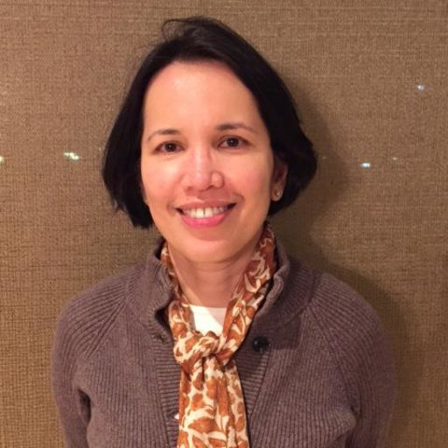
Rotua Lumbantobing is Vice President of the American Association of University Professors, elected in 2024 as part of the United Faculty for the Common Good slate. She’s a Professor of Economics at Western Connecticut State University, where she led the AAUP chapter and successfully fought to keep social science programs alive. Her research focuses on sports and inequality, with work on NBA expansion, Asian American diversity, and a forthcoming book on the U.S. women’s soccer team.

Rotua holds a BS in electrical engineering from the University of Indonesia, an MBA from the University of Rochester, and both a master’s and a PhD in economics from North Carolina State University. When she’s not analyzing power plays in higher ed or sports, she’s out logging miles—she’s a dedicated marathon runner with a serious streak of endurance, on and off the track.

See abstract of Rotua’s talk below:

This Fight is Yours: Organizing, Power, and the Future of AAUP

One year ago, Todd, Danielle, and I were elected to lead the AAUP at a time of deep crisis—and a clear call for change. We knew the challenges would be real, but we stepped in with one goal: to organize, build power, and put members at the center.

In this talk, I’ll share where we started, what we’ve faced, and the choices we’ve made to move forward—from defending academic freedom and labor rights to confronting attacks on public education. I’ll talk about the work of expanding our base, building coalitions, and forging a strategy to win.

Most importantly, we need your input. Because this fight isn’t about a few leaders at the top—it’s about all of us. Our strength is in numbers. If we organize with purpose and act together, we have the power to win.

PLEASE MARK YOUR CALENDARS FOR THIS INSPIRING MESSAGE FROM ROTUA LUMBANTOBING!

AAUP Chapters Adopt Mutual Defense Resolution

All Colorado Conference officially recognized chapters have endorsed the institutional solidarity resolution (see below) intiatied by the CSU-Fort Collins chapter. The resolution will be a topic of discussion at the annual meeting on June 14, 2025.

Resolution to Establish a Mutual Defense Compact for Colorado Institutions of Higher Education to Defend Academic Freedom, Institutional Integrity, and the Research Enterprise¹
Whereas, politically motivated actions by federal bodies pose a significant threat to the foundational principles of American higher education, including the protection of free speech, the autonomy of university governance, and the integrity of scientific research;
Whereas, the Trump administration and aligned political actors have targeted individual institutions with legal, financial, and political sanctions designed to undermine their public mission, silence dissenting voices, and/or exert improper control over academic inquiry;
Whereas, the preservation of one institution’s integrity is the concern of all, and an infringement against one Colorado institution of higher education shall be considered an infringement against all;
Be it resolved that, the Faculty Council of Colorado State University urges the President and Board of Governors of Colorado State University as well as the Chancellor of the Colorado State University System to formally propose and help establish a Mutual Academic Defense Compact (MADC) among all Colorado institutions of higher education, including the Community College System as well as regional partners;
Be it further resolved that, under this compact, all participating institutions shall commit meaningful funding to a shared or distributed defense fund. This fund shall be used to provide immediate and strategic support to any member institution under direct political or legal attack;
Be it further resolved that, participating institutions shall make available, at the request of the institution under direct political infringement, the services of their legal counsel, governance experts, and public affairs offices to coordinate a unified and vigorous response, including but not limited to: Legal representation and countersuit actions; strategic public communication; amicus briefs and expert testimony; legislative advocacy and coalition-building; related topical research as needed.
Be it finally resolved that, this resolution be transmitted to the leadership of all Colorado institutions of higher education and their respective governing boards and shared governance bodies, and that the Chancellor of the Colorado State University System take a leading role in convening a summit of the legal leadership of Colorado institutions of higher education to initiate the implementation of this Compact.

¹This document is based on the resolution recently passed by the faculty senates of Rutgers University, Michigan State University, Indiana University, University of Nebraska Lincoln, and other members of the “Big Ten.”

Financial Transparency Initiative

The Conference received disappointing news from the Colorado Department of Higher Education concerning the financial transparency initiative the General Assembly this past session. According to CDHE’s Rachel Fischer the Joint Budget Committee failed to act on CDHE’s recommendation that financial reporting at R-1 state universities be streamlined and made more accessible. Whether the measure will be taken up next year remains uncertain. So, for all practical purposes we are back to square one.

The financial documents we wish to obtain more ready access to are the following:

- Institution-specific financial audits for last five years
- Any documents included in preparation for an audit for a specific institution or where an institution was audited as a part of a larger system, such as CCCS
- The names of workers with responsibilities to prepare institutional financial audit data
- Annual budgets for last five years
- Form 990 for the last five years
- Salary and title information for every employee for the last five years
- Organizational charts
- All contracts between the institution and external vendors
- All requisitions above $100,000 submitted for external bids and the successful, accepted bid for 60 days following its acceptance

The ExCom encourages Colorado AAUP chapters to join in this effort to improve institutional budget and financial transparency. We hope to raise this issue with the legislature in coming legislative sessions.

Legislative News

National Day of Action Raises Awareness of Threats to Faculty and Academic Freedom

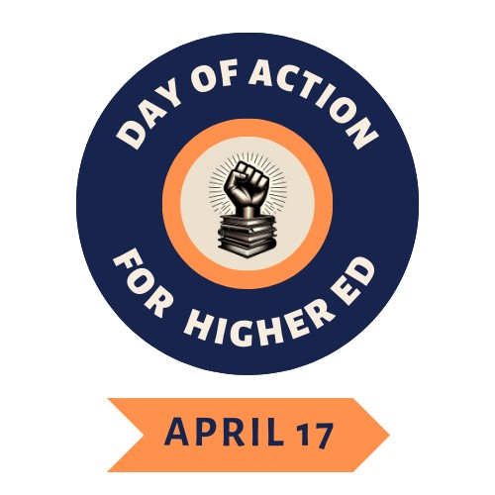

The AAUP supported Coalition for Action in Higher Education’s National Day of Action was a tremendous success. Across the country an estimated 20,000 turned up on campuses and in our Hawai’i and Alaska to New York City, from Washington D.C. to Washington State, faculty organized and mobilized in almost 200 distinct actions – including rallies, protests, teach-ins, walkouts, banner drops, art installations, anti-fascist office hours, flash mobs, watch parties, and more! 14 nationally live streamed webinars included thousands of guests throughout the day. Combined, these webinars and actions enacted a commitment to “Free Higher Education Now!” from debt and austerity regimes, from carceral tactics deployed against our colleagues and students, from coercive control by boards of governors and trustees, from the collapse of academic freedom in the face of anti-war and Palestine solidarity protests, and from the refusal to center humanity and knowledge as a liberatory path to justice. Kudos to all our Colorado AAUPers who made this a success on their campuses!
Contributed by Karim Mattar, CU-Boulder

___________________________
Colorado Views
Why You Should be Unrelentingly Hostile to AI

Jonathan Rees

This post is about the biggest threat to the jobs of college professors in America today. No, not that guy. Not the guy with the chain saw either. I’m writing about that other subject that you’re sick of reading about because it just makes you depressed.

I first wrote about AI last September rather reluctantly because I really wasn’t sure I had anything to add to the discussion I got over that hesitation because nobody had really described to me exactly what AI was and why everyone had started talking about it at that moment until my old friend Jonathan Poritz visited campus and did both of those things. Long story short: It’s not that big a leap between the technology we had before all the hype started and what we have now. Also, the writing it produces is really bad.

That proved to be a pretty good resting place for my mind on this topic. Whenever someone asked me about AI since (which admittedly doesn’t happy a lot but has actually happened), explained that it’s not a bif leap between the technology we had before all the hy[e started and that the writing it produces is really bad. When I somehow managed to run an entire fifty-minute discussion on this subject in my Introduction to History for majors class last spring, I deliberately saved the ethics of the subject for the last five minutes because I thought attacking AI in practical terms first would be much more effective.

Sadly, this argument hasn’t been quite as effective as I had originally hoped. When I do make this argument, some people say stuff to me along the lines of, “Since we know that AI is the future, we as professors have to teach our students to use it responsibly,” This then leads me to wonder if my only job in the near future is going to be to teach undergraduates how to come up with better prompts and whether anyone will be willing to pay me for that.

Luckily for me, since I still read all the depressing articles about AI that I see, I came across the perfect counter to that position this morning. The author is Nicholas Carr, the author of The Shallows, among other great books about technology:

“Automation is most pernicious . . . when a machine takes command of a job before the person using the machine has gained any direct experience doing the work. Without experience, without practice, talent is stillborn. That was the story of the ‘deskilling’ phenomenon of the early Industrial Revolution. Skilled craftsmen were replaced by unskilled machine operators. The work sped up, bit the only skill the machine operators developed was the skill of operating the machine, which in most cases was hardly any skill at all. Take away the machine, and the work stops . . .

Generative AI enables students to produce the product without doing the work. Rather than reading and making sense of difficult source texts, they can ask a chatbot to gin up simplified summaries. Rather than synthesizing various ideas and perspectives through concerted thinking, they can ask the chatbot for a generic synthesis. And rather than expressing (and refining) their thoughts through composition of sentences and paragraphs, they can get the bot to spit out a first draft or even a final one. The paper a student hands in no longer provides evidence of the work of learning its creation entailed. It is a substitute for work.”

That is why I am unrelentingly hostile to AI and you should be too. It’s not about saving your job per se, it’s about justifying why your job is important in the first place.

Jonathan Rees is a contributing editor at Academe Blog where this piece first appeared, professor of history at CSU Pueblo, and President of CSU-P’s AAUP chapter.

AAUP Summer Institute
The AAUP Summer Institute, held this year at Morehouse College in Atlanta, Georgia, is open for registration at this link: Summary - 2025 Summer Institute . First time participants may apply for travel assistance from the Colorado Conference. Up to 3 stipends may be awarded. Reach out to either Aaron Schneider or Steve Mumme for details.

AAUP Redbook, 12th Ed.

We are pleased to report that the new Redbook will be available for distribution to chapter presidents at the Annual Meeting, June 14. Please let Aaron Schneider know whether you will be available to pick up a copy—so we have copies available at the meeting.

Chapter EIN Access

AAUP Colorado chapters needing an EIN to create bank accounts can access that information at the IRS website. Link is:
Get an employer identification number | Internal Revenue Service
Chapters with accounts under $50,000 need not file for tax exempt status according to advice from national AAUP.
------------------------------------------------------
Conference Election Results

With 58 ayes and no nays, the slate of candidates for conference elective office was approved by member in May. These are the individuals currently listed in leadership below: Aaron Schneider, Steve Mumme, Don Eron, Rachael Lehman, Melinda Myrick, and Kamran Sahami. Our profuse thanks to all those who registered their vote for this periodic and very necessary function.

Chapter News
AAUP-DU. Aaron Schneider reporting.
AAUP CSU-Pueblo.
AAUP-CSU-Fort Collins

U. Colorado, Colorado Springs
ADD NEW LEADERSHIP

Fort Lewis College

Legislative Report

Conference Leadership

Co-President, Stephen Mumme, CSU-Ft. Collins, stephen.mumme@colostate.edu’
Co-President, Aaron Schneider, DU Aaron.Schneider@du.edu

Vice-President for Administrative Matters, Don Eron, UC Boulder, donmarcuseron@gmail.com

Vice-President for Legislative Affairs, Rachael Lehman, CCD, lehman.rachael@gmail.com

Vice-President for Community College Affairs, Melinda Myrick, FRCC

Secretary/Treasurer, Kamran Sahama, Metropolitan State University Denver, ksahami@gmail.com

Webmaster, Jonathan Rees, CSU Pueblo
drjonathanrees@gmail.com

At Large Representative
Bill Timpson, CSU-Ft. Collins, william.timpson@colostate.edu

Colorado Conference Chapter Officers

Colorado Mountain College
Dave Ruffley, Chapter President
dlrwy@yahoo.com
*CMC locations in Aspen, Breckenridge, Carbond
ale, Dillon, Glenwood Springs, Leadville, Rifle,
Salida, Spring Valley, Steamboat Springs, Vail Valley
Colorado College, Colorado Springs
John Horner, President
jhorner@coloradocollege.edu

Colorado State University, Ft. Collins
Mary Van Buren, President
mary.vanburen@colostate.edu
Colorado State University, Pueblo
Jonathan Rees, President
drjonathanrees@gmail.com
Community College of Denver
Tim Benson, President
timothy.benson@ccd.edu
Ft. Lewis College, Durango
Kathryn Linares-Gray, Chapter President
kllinaresgray@fortlewis.edu
Front Range Community College,
Westminster
Melinda Myrick and Mark DuCharme,
Chapter Co-Presidents
mel.myrick8@hotmail.com
markducharme@gmail.com

Naropa University, Boulder
Travis Cox and Stephen Polk,
Chapter Co-Presidents
tcox76@hotmail.com
spolk@naropa.edu
Regis University, Denver
Karen Adkins, Chapter President
kadkins@regis.edu

University of Colorado, Boulder
Marki LeCompte, Chapter President
margaret.lecompte@colorado.edu

University of Colorado, Colorado Springs
Dylan Harris, President
dylan.matthew.harris@gmail.com
University of Denver
Aaron Schneider, Chapter President
Aaron.Schneider@du.edu
University of Northern Colorado,
Greeley
Karen Barton, Chapter President
karensbarton@gmail.com

