AAUP ALERT
Colorado Conference
Spring 2026 Newsletter
Contents
- Co-Presidents’ Message
- Annual Meeting Announcement
- No Kings in America Rally
- Chapter Bank Account Guidance
- AAUP Colorado T-Shirts
- Friend of Higher Ed Award
- Myron Hulen Award
- Colorado Voices
- Candidate Endorsements
- Legislative Matters
- Chapter News
- Conference Leadership
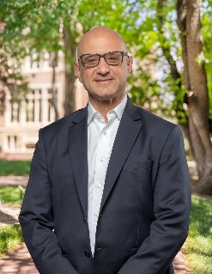
Co-Presidents’ Message

As spring semesters and quarters wind down our Colorado Conference chapters have never been busier in the tasks of defending academic freedom and shared governance. The chapter reports in this newsletter reveal much of what is crowding our respective agendas across the state. Our Mutual Defense Resolution has gone forward. Chapter activists are fighting budget cuts and unnecessary layoffs brought on, at least in part, by unjustified federal cuts to institutions and the State of Colorado. The rapid deployment of Flock Camera surveillance on campus encroaches on faculty and student privacy, a further threat to our immigrant students, among others. Cavalier deployment of AI technology challenges instruction, learning integrity, and academic freedom. Such threats to faculty and students require a vigorous AAUP response and are sure to be front and center at the national AAUP Biennial Meeting, June10-13, 2026, in Chicago. Here in Colorado, we will also have an opportunity to discuss these issues at our Annual Meeting, scheduled just after the Biennial in June (see announcement below). We hope to see you there.

Antonio Gallo to Keynote Colorado Conference Annual Meeting at Denver University

We are pleased to announce that Region 1 AAUP National Council member, Antonio Gallo will headline our annual meeting, scheduled for June 20, 2026 at Denver University’s SIE International Complex.

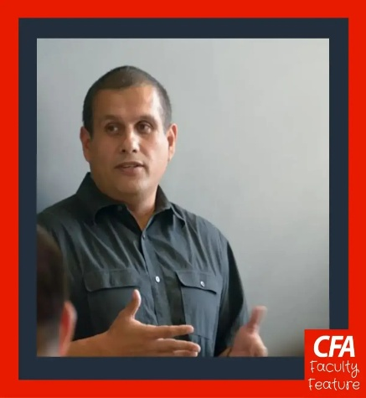

An attorney and lecturer at California State University, Northridge, Gallo represents our 13-state Region 1 district on the AAUP National Council. He has been a lead negotiator for the California Faculty Association (CFA) and serves as chair of CFA’s Contract Development & Bargaining Strategy Committee, co-chair Faculty Rights at CFA Northridge, vice-president lecturer representative at CFA Northridge, and a member of CFA’s Chicanx/Latinx Caucus. In 2022 he was recognized by the greater Los Angeles branch of the California Democratic Party as one of its Democrats of the Year.

CSU-Fort Collins Leads at No Kings Rally, March 28

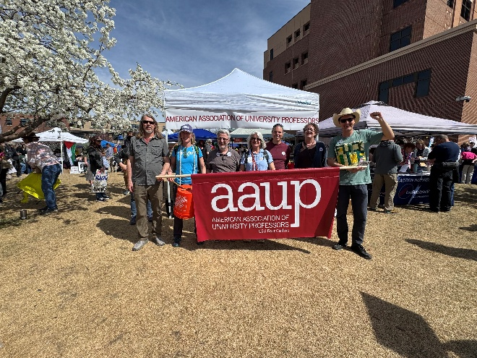
From left to right: John Kitchens, Gretchen Steidley, Dimitris Stevis, Louise Jennings, Brian Munsky, Mary Van Buren, and Anders Fremstad

AAUP Fort Collins participated in a leading role at the recent No Kings rally in Fort Collins where nearly 10,000 Fort-ifiers expressed their outrage at King Donald’s assaults on rule of law, ill-considered tariffs, and reckless war on Iran while joyously engaging in an unprecedented display of democratic solidarity. CSU-FC AAUPer and speech communication professor Karrin Anderson gave the rally’s keynote speech before Fort-ifiers set out on a 2-hour march through the downtown area.

Ginning up support for AAUP and No Kings, chemical and biological engineering professor Brian Munsky created an interactive app promoting AAUP and other participating organizations (see example below).

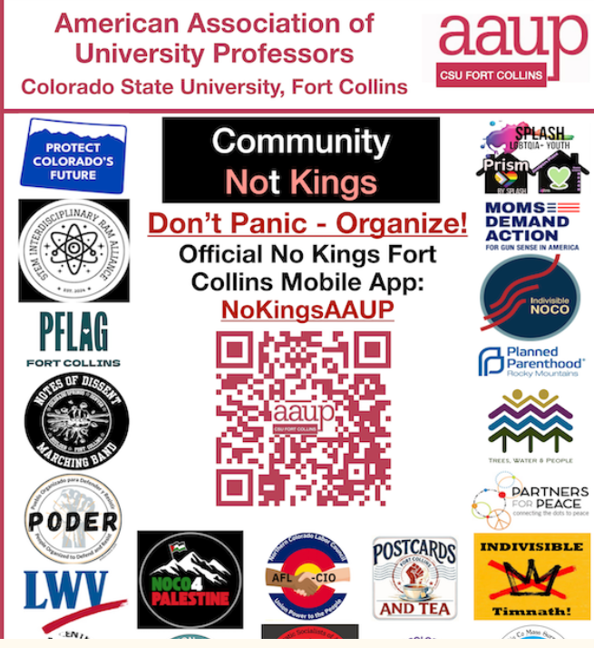

New Guidance on Establishing Chapter Bank Accounts

An essential function instrumental for establishing robust AAUP chapters is the creation of a chapter bank account enabling chapters to receive and expend funds. Responding to several inquiries this year from newly formed chapters, the Conference has written a one-pager explaining basic procedure for establishing a chapter bank account. Please do not hesitate to contact Steve Mumme or Aaron Schneider if you need a copy of these guidelines. We hope to have these posted to the website soon.

AAUP Colorado Conference T-Shirts

The Colorado Conference has purchased 100 t-shirts that will be available on a first-come, first-served basis at the annual meeting in June. Our new shirts, purchased from Artist Proof Collective, a union shop in Denver, look like this:
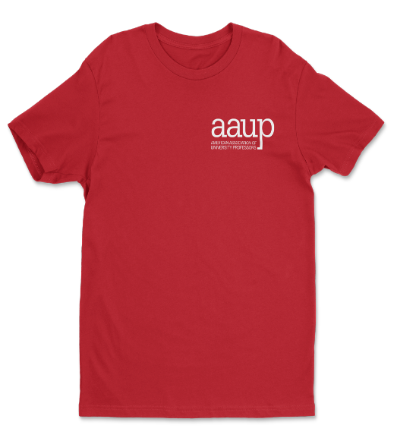
Backside has: AAUP Colorado Conference, Academic Freedom for a Free Society.

Journalist Elizabth Hernandez honored with Friend of Higher Education Award

Elizabeth Hernandez covers social justice and equity issues at the Denver Post, where she won the 2020 Colorado Press rising star award. She has covered education, including higher education, always drawing on her own vision as a first-generation graduate of CU Boulder, giving voice to underrepresented students and educators. Her coverage of the University of Denver has been especially powerful and important to the many faculty, staff, and students who care about higher ed.”


Elizabeth Hernandez
Katherine Crowe (DU AAUP) reports that in the last few years, Hernandez has ensured that her reporting on the University of Denver and other institutions of higher education balances the voices of university spokespeople with those of faculty, students, staff, and community members. She foregrounds her reporting with her lived experience as a first-generation student, something she consistently includes in her bios and introductions. In her story on the rollback of DEI initiatives on the DU campus, she centered student voices, ensuring that senior leadership were not the only voices speaking to the issue. These efforts to center educators are also evidence in her recent story on cuts to teacher recruitment programs by the Colorado legislature, an issue affecting both K-12 and higher education students as well as faculty. This is also evident in her student-centered coverage of what Metro State is doing to support working parents. Her marathon coverage of the three-day bargaining session the Denver Classroom Teachers' Association (DCTA) went through following their strike in 2019 also highlights her strong labor focus, which is not surprising given her vocal opposition to "vulture capitalism" (private equity and hedge funds') role in journalism and her own involvement in the Denver Post Newspaper Guild, including her participation in a protest she and many other staffers at the Post and other organizations owned by Alden Global Capital in 2018. As she told the New York Times, "I don't like being the story," but that shows how determined she's been over the past decade + to ensure that the voices of those most impacted by changes to the structures that impact higher education and media in the state of Colorado are centered.

The FoE Award will be bestowed at the conference annual meeting in June 2026.
Long-time Activists Margaret LeCompte and Mark DuCharme honored with Myron Hulen Award.

Two of Colorado’s outstanding and long-serving chapter activists will be recognized at our June 2026 Annual Meeting with the conference Myron Hulen Award. The award is given to chapter activists who have served both their chapter and contributed to Colorado Conference work for an extended period of time. Margaret LeCompte, our longest serving member of the conference executive committee other than Dean Saitta and Steve Mumme, led the AAUP’s CU-Boulder chapter for nearly 20 years championing academic freedom and shared governance, seeing it through the controversial assault on indigenous studies professor Ward Churchill and defending CU faculty members and those at other institutions from threats of dismissal.
Mark DuCharme, a Co-President of the Front Range Community College chapter,
has served the chapter and conference since 2012, helping spearhead Colorado Community College System reforms that improved the representation of adjunct faculty within CCCS and secured highest tier transfer renumeration for adjunct faculty teaching across the Colorado community college system. Both have been pillars of their chapters and the Colorado Conference. We salute them!

Colorado Voices
Textbook Access at CSU-Pueblo
by Jonathan Rees

At the end of the 2024-25 academic year, the CSU Pueblo administration announced that Barnes & Noble would be taking over the campus bookstore. Accompanying that takeover, they also announced a new program called "PackReady" that would "help" students to have all their textbooks on the first day of class. While these kinds of agreements have become increasingly common at universities around the country, the details of PackReady are particularly bad for students and faculty alike. That's why the CSU Pueblo AAUP has devoted a great deal of effort this year towards trying to get the PackReady program terminated.

With limited space in this newsletter, let's concentrate on the problems with the program that affect faculty the most. First, our faculty have no way to opt out of the program. Many CSU Pueblo professors use nothing but Open Educational Resources (OER) yet students participating in PackReady are being charged $75 for a three-credit course to gain access to textbooks that are supposed to be free. Before PackReady, our library and many faculty members received grants to help create OER resources. Now, we aren't even eligible for these incentives.

Second, faculty have no control over the format of the books that students get under the program. If you want your students to have a physical textbook so they can take notes in it, Barnes & Noble may very well give them an electronic text. Moreover, PackReady textbooks are all rentals, so if you use the same text for multiple classes your students are going to have to rent again. On a related note, if you assign your students a textbook that is from a publisher that Barnes & Noble hasn't cut a deal with already, students are charged separately for that text besides the $75/course they get charged just for participating in the program.

Third, this whole agreement has been a shared governance disaster. Our administration signed the agreement with Barnes & Noble before they ever told us about the program. Then, they presented it to the Faculty Senate as a fait accompli, assuming that faculty would quietly go along with despite various aspects of the arrangement infringing upon our academic freedom.

The CSU Pueblo AAUP is currently petitioning against the PackReady program amongst both faculty and students for the conducted research on faculty obligations to deal with an outside entity, Barnes & Noble, and have discovered that there is no actual policy that compels us to tell them what our book orders are. Obviously, we have passed this intriguing news on to as many CSU Pueblo Faculty as possible. As a result, hopes are high that we can at least compel our administration to renegotiate the agreement with Barnes & Noble before the start of the fall semester.

Original version published in Academe Blog

Legislative Matters

HB26-1005 Worker Protection Collective Bargaining. The latest collective bargaining bill has now passed the House of Representatives and the Senate and is now headed Gov. Jared Polis’ desk. The bill benefits from a very low fiscal note based on proposed administrative reductions to the Colorado Labor Peace Act.

As written, the bill eliminates the Labor Peace Act’s requirement of a second election to create a union bargaining unit. Importantly, the bill as written does not exclude higher education, though further legislation may be needed to clarify its protections for faculty.

Now that it has passed the General Assembly, Polis’ willingness to sign the bill remains in doubt.

Midterm Elections 2026: Candidate Endorsements

For the first time in the life of our conference, we are encouraging chapters to consider endorsing candidates in the upcoming primary and general elections this year. We have determined that candidate endorsements will not adversely affect our non-profit 501c4 status should we elect to obtain that status at some future date.

Chapters looking to frame questions for candidates are advised to consult the AAUP’s just issued Blueprint for Strengthening and Transforming Higher Education.

The Executive Committee, meeting in March 2926, also considered asking candidates for the following commitments:
Collective Bargaining Rights
- Support repeal of the second vote requirement of the Colorado Labor Peace Act. [There should not be a higher voting threshold for forming a union (75%) than from amending Colorado's Constitution (60%).]
- Support collective bargaining for all higher education workers, including faculty, non-classified staff, and graduate student employees.
Higher Education Administration and Funding
- Commit to pursue repeal TABOR.
- Commit to bring per-pupil state funding for higher education to the national median.
- Support budgetary transparency for Colorado higher education institutions.
- Support data privacy for international and undocumented students.
- Support the principle of mutual defense in countering Trump’s assaults on Colorado higher education.

Chapter News

AAUP CU-Boulder

The Boulder chapter had had a victory in that the university delayed access to ChatGPT Edu to students until August owing to instructional concerns related to AI deployment in the classroom.

The AAUP-Boulder Chapter has also been involved in interviewing CU Regents candidates for our region and will issue an endorsement ahead of the election. And, in collaboration with United College Workers (UCW—the wall-to-wall union), we’ve successfully secured a strong vote in support of collective bargaining from the Boulder Faculty Assembly, and the formation of a BFA-sponsored committee/working group (Deb Palmer chairing) in collaboration with a similar committee at CU Denver to explore how collective bargaining might work together with shared governance.

Chapter Co-President, Jed Brown, has also been organizing with a group of faculty and students to demand meaningful shared governance in relation to the OpenAI contract and future university strategy. They argue the process leading to the contract betrayed Regent Law 5.A granting faculty "principal responsibility" for matters of pedagogy, curriculum, and academic ethics. The contract has serious consequences on all those matters, and claims by administration that faculty can set their own policies are belied by the financial incentives they are offering for specific (controversial and largely not evidence-based) pedagogy choices. Moreover, "AI" detection software has high false-positive rates with racial/nationality/dialectic bias in those false positives, people overestimate their ability to identify such content, and many anxious students self-surveil to be able to fight false allegations of use. Attempts by faculty to build the mutual trust necessary for students to voluntarily choose to experience the intellectual fraction of learning despite no credible threat of enforcement are undermined by university leadership pitching the opposite. This issue has dominated shared governance over the past two months, and it is necessary to keep pressure on from multiple angles in order for faculty and subject-matter experts to have any say in these AI decisions going forward. A detailed critique of the OpenAI contract may be obtained by request from Jed Smith (or Steve Mumme)
Deb Palmer and Jed Smith reporting.

AAUP CU-Colorado Springs

Our chapter has successfully engaged with the broader governance of our institution by offering support through ongoing difficult budget conversations. We have been tasked with finding ad hoc legal services, which have been fruitful. Additionally, we are working with colleagues to move forward with an event that discusses unequal pay alongside colleagues from CU Denver and CU Boulder. Our chapter has also worked alongside UCW to push for collective bargaining, resulting in a resolution - presented to the faculty assembly by an elected rep - being brough forward to faculty assembly today. The goal is to vote on it next month. Finally, our chapter decided to hire Howard Bunsis again for a 3-year update report to see if any of the data discrepancies and issues he raised in the first forensic report have been addressed.
Dylan Harris reporting
AAUP Colorado College

The Colorado College AAUP has been working on several issues pertaining to shared governance such as revision of the existing intellectual property policy. We are collaborating with the Faculty Executive Committee about workplace practices that are concerning because they were developed and implemented without faculty input. We also prepared and submitted a report about faculty salaries to the Compensation Committee and the FEC.
Phoebe Lostroh reporting

AAUP Front Range C.C.
Our chapter is concerned about the potential impacts of the Trump administration's malicious immigration policies on immigrant communities among our student population and among staff and colleagues. We have assembled "swag bags" with know-your-rights information and whistles for distribution on our Westminster campus. We also have connected with a group of students who are trying to offer support and solidarity to their peers who may be affected by this. Most recently, we have become aware of a potential major change in how the CCCS conducts education in our state. This is a developing situation with potentially far-reaching impacts. We will keep you posted.
Mark Ducharme reporting
Fort Lewis College
We have been working on a couple things this semester. We wrote a new version of the mutual defense compact that we are calling the Colorado Higher Education Mutual Academic Defense Alliance. Sarah Roberts-Cady sent that document out to the AAUP folks a couple months ago. Since then, we have successfully rallied out Faculty Senate—they passed it in resolution form and subsequently sent it out to the faculty leadership at the various Colorado colleges and universities. Since then, our chapter has written and endorsed a statement opposing the use of Flock cameras on our campus and requesting that they be removed immediately. We are hoping to introduce that statement as a resolution in our Faculty Senate in the next couple of weeks. Beyond that, we have been working to determine the extent of our right as faculty to prohibit recording in our classrooms.
Kathryn Linares-Gray reporting

Conference Leadership

Co-President, Stephen Mumme, CSU-Ft. Collins, stephen.mumme@colostate.edu’
Co-President, Aaron Schneider, DU Aaron.Schneider@du.edu

Vice-President for Administrative Matters, Don Eron, UC Boulder, donmarcuseron@gmail.com

Vice-President for Legislative Affairs, Rachael Lehman, CCD, lehman.rachael@gmail.com

Vice-President for Community College Affairs, Melinda Myrick, FRCC

Secretary/Treasurer, Kamran Sahami, Metropolitan State University Denver, ksahami@gmail.com

Webmaster, Jonathan Rees, CSU Pueblo
drjonathanrees@gmail.com

At Large Representative
Bill Timpson, CSU-Ft. Collins, william.timpson@colostate.edu
Colorado Conference Chapter Officers

Colorado Mountain College
Jeff Runyon, Chapter President
jrunyon81@gmail.com
External
*CMC locations in Aspen, Breckenridge, Carbond
ale, Dillon, Glenwood Springs, Leadville, Rifle,
Salida, Spring Valley, Steamboat Springs, Vail Valley
Colorado College, Colorado Springs
Phoebe Lostroh, President
plostroh@coloradocollege.edu

Colorado State University, Ft. Collins
Mary Van Buren, President
mary.vanburen@colostate.edu
Colorado State University, Pueblo
Jonathan Rees, Co-President
drjonathanrees@gmail.com
Heather Hopkins-Bowers
hmhopkinsbowers@gmail.com

Community College of Denver
Tim Benson, President
timothy.benson@ccd.edu
Ft. Lewis College, Durango
Kathryn Linares-Gray, Chapter President
kllinaresgray@fortlewis.edu
Front Range Community College,
Westminster
Melinda Myrick and Mark DuCharme,
Chapter Co-Presidents
mel.myrick8@hotmail.com
markducharme@gmail.com

Naropa University, Boulder
Travis Cox and Stephen Polk,
Chapter Co-Presidents
tcox76@hotmail.com
spolk@naropa.edu
Regis University, Denver
Karen Adkins, Chapter President
kadkins@regis.edu

University of Colorado, Boulder
Deborah Palmer, Co-President
debpalme@gmail.com
Karim Mattar, Co-President
kmattar001@gmail.com
Jed Brown
jed@jedbrown.org

University of Colorado, Colorado Springs
Dylan Harris, President
dylan.matthew.harris@gmail.com
University of Denver
Aaron Schneider, President
Aaron.Schneider@du.edu
University of Northern Colorado,
Greeley
Karen Barton, Chapter President
karensbarton@gmail.com
Western Colorado University
Brian Bernhardt, Chapter President
brianbernhardtaaup@protonmail.com

